Lab 1: Exploring Cloud Virtualization
and Data Center Architecture

Student Name:
Omar Mohamed Hussein Said

Group:
SE3

Date:
April 25, 2026

Part A: VM vs Container Comparison
In this part, I launched an Ubuntu VM using Multipass and a Docker container, then measured and compared their resource usage using three commands: free -h, ps aux, and df -h.

Container Resource Usage (Docker)
The following screenshot shows the resource measurements taken inside the Docker container:
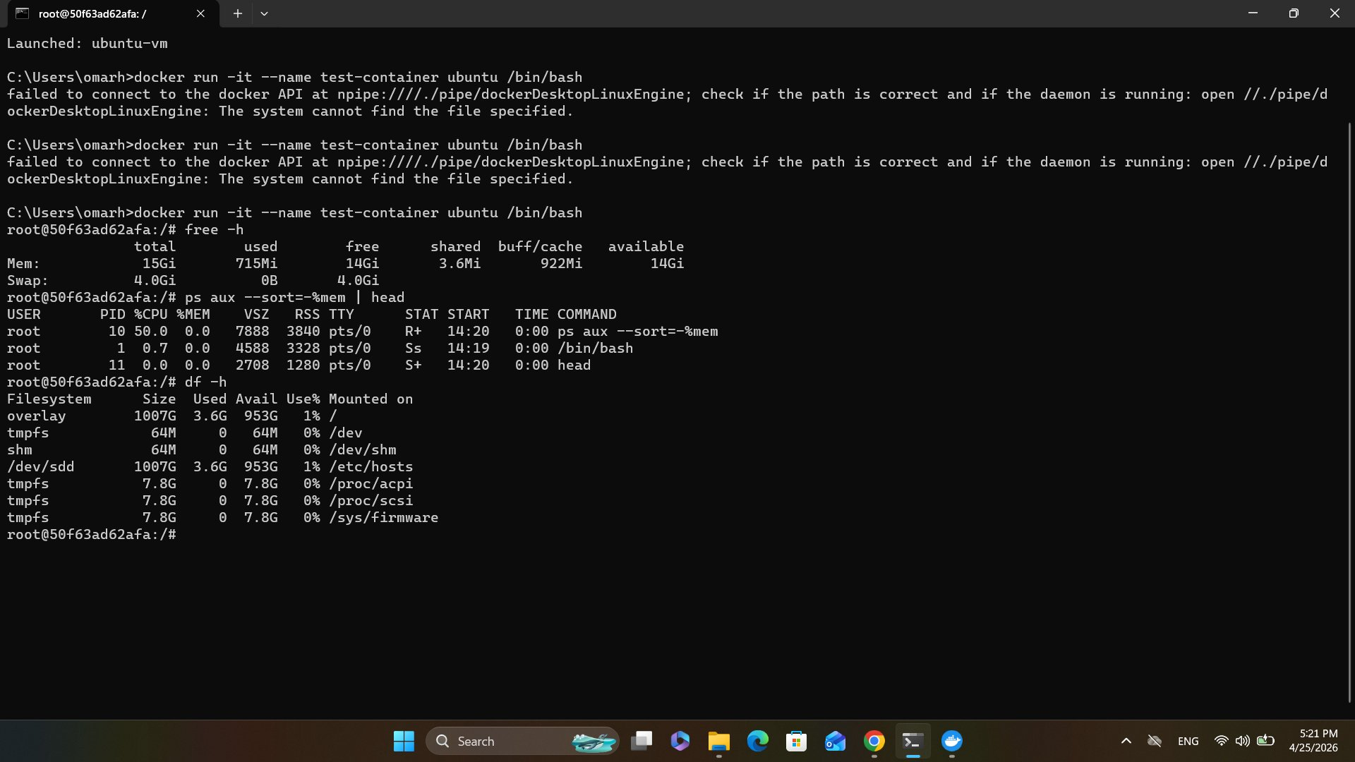
Figure 1 — Docker container: free -h, ps aux, and df -h output

VM Resource Usage (Multipass)
The following screenshots show the resource measurements taken inside the Multipass Ubuntu VM:
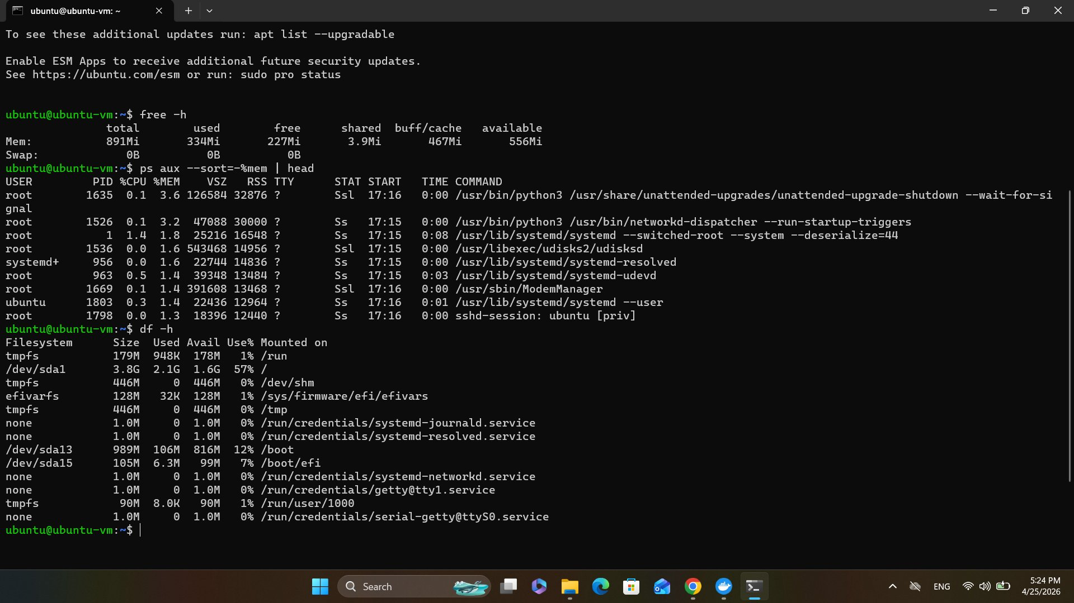
Figure 2 — Multipass VM (Command Prompt): free -h, ps aux, and df -h output

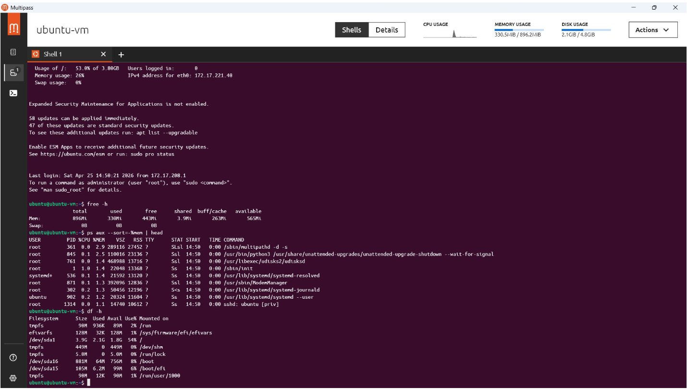
Figure 3 — Multipass VM (GUI shell): free -h, ps aux, and df -h output

Comparison Table
Metric | Container (Docker) | VM (Multipass)
Total Memory | 15 GiB (shared host) | 891 MiB (dedicated)
Memory Used | 715 MiB | 334 MiB
Processes | 3 (only bash + ps + head) | 10+ system services
Disk (root) | 1007 GB overlay (shared) | 3.9 GB dedicated disk
Startup Time | ~3 seconds | ~3-5 minutes
Isolation | Process-level (kernel shared) | Full OS isolation

Analysis
Memory Usage
The Docker container reported a total of 15 GiB of memory — this is actually the host machine's RAM, since containers share the host kernel and do not have dedicated memory allocation. The VM was allocated 891 MiB of dedicated RAM with 334 MiB in use, showing that the hypervisor gives the VM its own isolated memory space.
Process Count
Inside the Docker container, only 3 processes were running: bash, ps, and head — the exact minimum needed. In contrast, the VM was running 10+ background system services including systemd, networkd, ModemManager, udisksd, and sshd. This confirms that the VM runs a full operating system stack while the container runs only what is needed.
Disk Usage
The container used an overlay filesystem that maps back to the host machine's disk (1007 GB shared). The VM had its own dedicated virtual disk of 3.9 GB. This further demonstrates the isolation difference — the VM has its own fully separated storage.
Startup Time
The Docker container started in approximately 3 seconds. The Multipass VM took 3 to 5 minutes on first launch because it had to download and boot a complete Ubuntu image, initialize systemd, and start all background services.

Part C: Tail Latency Simulation
In this part, I deployed a simple Flask web server that introduces a random exponential delay on every request. I then sent 100 sequential HTTP requests and measured the response time of each one to observe tail latency behavior.

Flask App Running in Browser
The screenshot below shows the Flask app responding in the browser with a random delay:
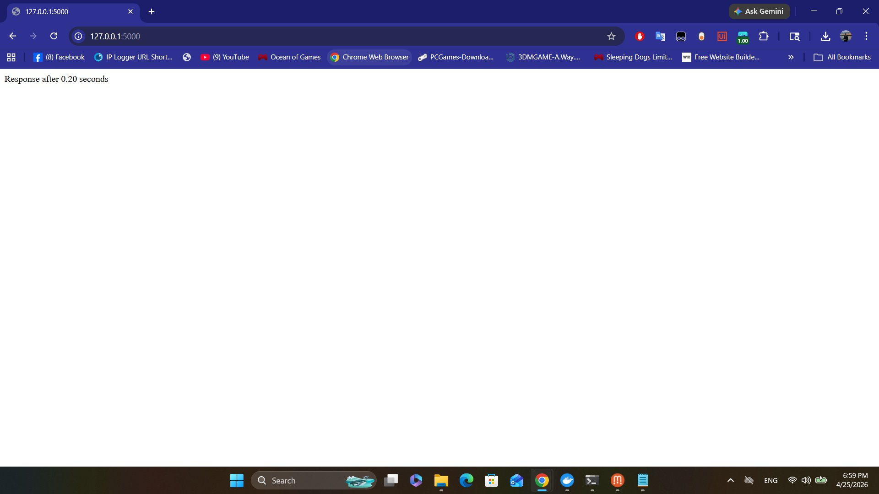
Figure 4 — Flask app running at http://127.0.0.1:5000 showing a random response time

Test Results — 100 Requests
The screenshot below shows the final results after sending 100 HTTP requests to the Flask server:
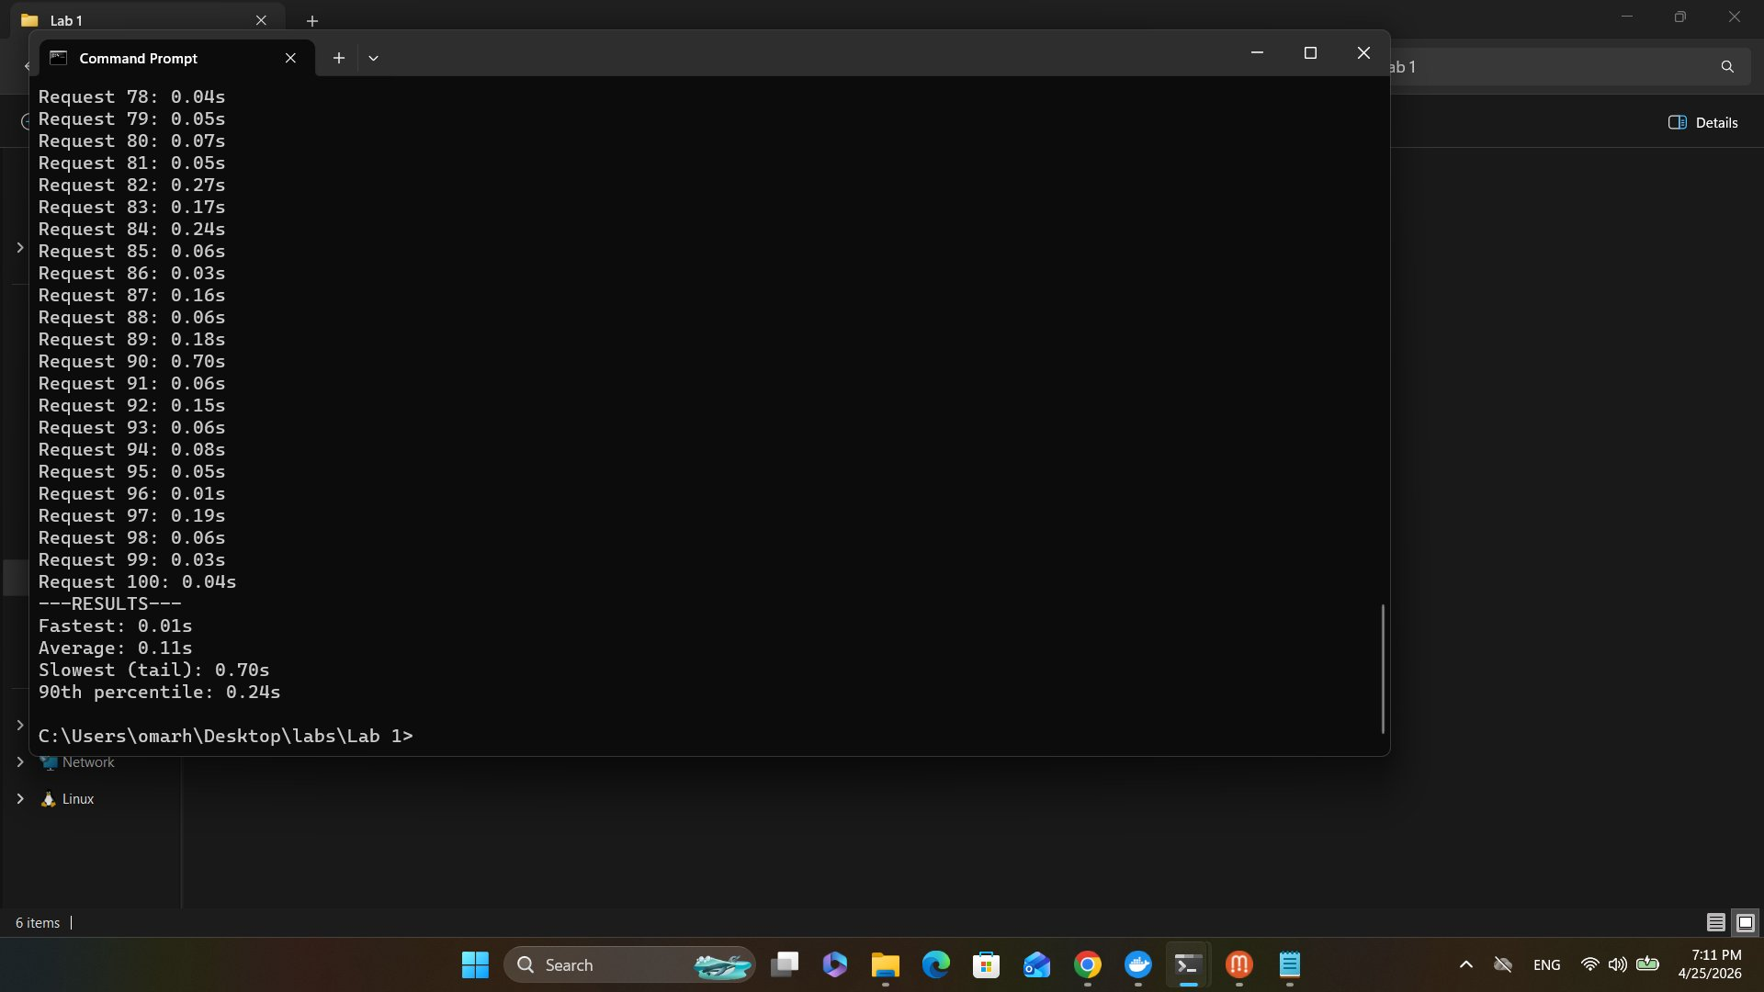
Figure 5 — Terminal output showing all 100 request times and the summary statistics

Latency Histogram
The histogram below visualizes the distribution of response times across all 100 requests:
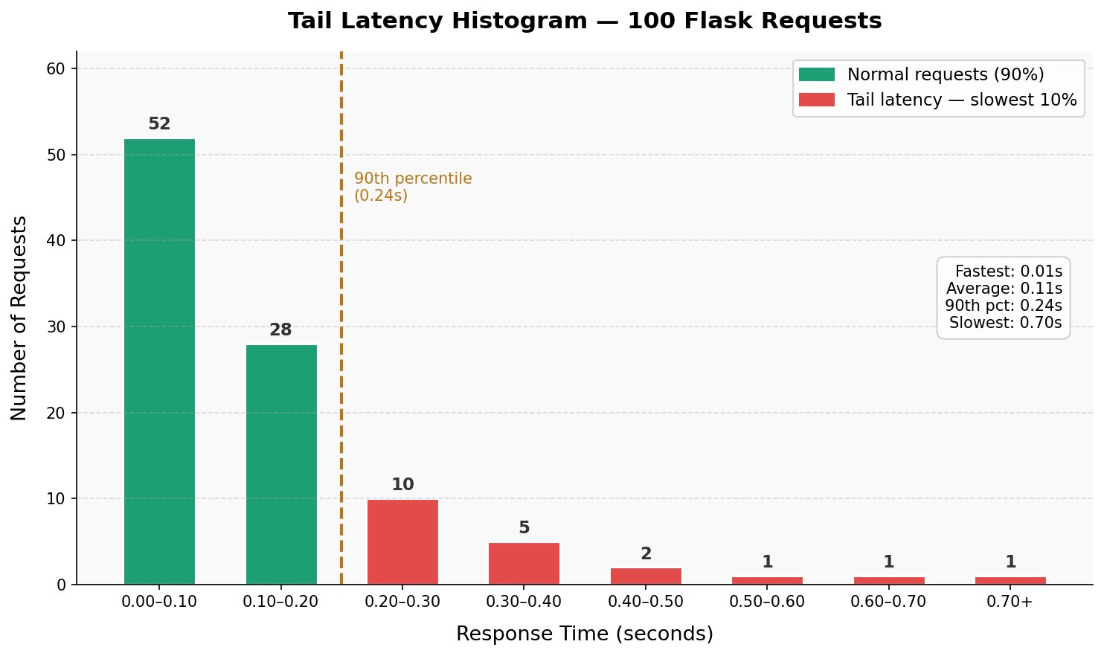
Figure 6 — Tail latency histogram showing exponential distribution of response times

Results Summary
Metric | Value
Fastest response | 0.01 seconds
Average response | 0.11 seconds
90th percentile | 0.24 seconds
Slowest (tail latency) | 0.70 seconds

Observation
The histogram clearly shows an exponential distribution. The majority of requests (80 out of 100) completed in under 0.20 seconds. However, a small number of requests took significantly longer, with the slowest reaching 0.70 seconds — 70 times slower than the fastest request. This is the classic tail latency pattern.
The 90th percentile was 0.24 seconds, meaning 9 out of 10 requests were fast, but 1 in 10 experienced noticeably higher latency. In a real data center handling millions of requests per second, this 10% tail becomes a significant user experience problem.

Short Writeup: VM vs Container for Microservices

Which Architecture is Better for Microservices?
Based on the results of this lab, containers are the better choice for microservices architectures. The reasons are:

- Containers start in seconds while VMs take several minutes. Microservices need to scale up and down quickly, so fast startup is critical.
- Containers use far fewer resources. The Docker container ran with only 3 processes while the VM ran 10+ background services. This means many more container instances can run on the same physical machine.
- Containers are lightweight and portable. Since they share the host kernel, there is no need to replicate an entire operating system per service.
- VMs offer stronger isolation with a dedicated OS, kernel, and memory space. This is better for security-sensitive workloads or when running different operating systems.

When to Use VMs Instead
VMs are the better choice when full OS isolation is required, when different operating systems must run side by side, or when applications require kernel-level access. For example, running Windows and Linux workloads on the same server requires VMs, not containers.

Conclusion
For modern microservices — where many small services must deploy and scale quickly — containers win on speed, density, and resource efficiency. VMs remain valuable for security isolation and OS-level separation. In practice, many cloud environments use both: VMs as the underlying infrastructure with containers running inside them, which is exactly what AWS does with Nitro hypervisors running Docker containers.

Discussion Questions

Why does AWS split Nitro into hardware components?
AWS Nitro offloads hypervisor functions (networking, storage, security) onto dedicated hardware cards instead of running them in software on the host CPU. This means the host CPU gives 100% of its resources to customer VMs rather than wasting cycles on virtualization overhead. It also improves security because the hypervisor runs on isolated hardware that customers cannot access, as demonstrated when we ran dmesg | grep -i nitro and could see Nitro but could not modify or access it.

In which scenarios would you use VMs over containers?
VMs are preferred when running workloads that require full OS isolation, different operating systems on the same host, kernel-level customization, or strict regulatory compliance (such as PCI-DSS or HIPAA) that requires hardware-level separation between tenants. Legacy applications that depend on a specific OS version also benefit from VMs.

How does tail latency change with the number of parallel calls?
Tail latency gets significantly worse as parallelism increases. When a request fans out to multiple services in parallel, the total response time is determined by the slowest individual call. For example, if a request calls 10 services simultaneously and each has a 1% chance of being slow, the probability that at least one is slow rises to roughly 10%. This is why Google and Amazon obsess over p99 latency — at massive scale, the tail becomes the bottleneck for nearly every user request.

